MEDA Project
(Michigan Electric Drive Aircrafts)

Projects Target: Recovery of Business operations to create a new Technology Experimental production and 100-500 working places in Oakland county, Michigan
Project Budget: 3.3 mil USD Total (1.2mil USD in 2020 and 2.1 mil USD in 2021-2022)
Project owner: George Rybchenko, ALTECHLAB of IT Network (Hi-Tech R&D Co., Walled Lake, MI) cell: (248) 872-5420, e-mail: altechlab1@gmail.com
Partners: -Henry Rise, Midwest Sky Sports (Light Aircraft Assembly, Caro, MI)
-Adam O'Connor, Michigan Avionics (Panels builder, Lapeer MI)
- Daniel Honer, CEO-Sterling Technology Inc. (Electro-Mechanical Solutions and Assemblies, Wixom, MI)

ALTECHLAB
2020
MEDA project (Michigan Electric Drive Aircrafts) is developing two new hybrid electric powertrains to enable cleaner, quieter and more efficient aircraft propulsion. by adopting a modular approach to propulsion system components design, for the first time two variants of a serial hybrid-electric powertrains will be tested in flight: the first uses a fuel-driven generator to charge the batteries and power the electric motor, while the second relies e-Drive only to use power enabling zero-emission flight. Data from flight tests will be used to model future operating scenarios of hybrid electric aviation paving the way towards greener aircraft.
The project is developing key technology and roadmap for market implementation of future hybrid-electric airplanes. After having completed successful ground demonstrations of a hybrid powertrain in previous project, MEDA will deliver new, optimized propulsion components with increased reliability suitable for in-flight testing and future commercial deployment to small aircraft. The first flights of two four-seat airplanes equipped with MEDA hybrid electric powertrains are scheduled for 2020.
The Modular Approach to Hybrid-Electric Propulsion Architecture (MEDA project) is developing the enabling propulsion technology for future small and regional passenger airplanes, capable of exploiting the existing small local airports to provide micro-feeder service to larger hubs and eliminating gaseous emission impact on surrounding communities. The project will develop new components in a modular way to power two four-passenger hybrid electric airplanes scheduled to fly in 2020. The first will be equipped with a hybrid powertrain utilizing an internal combustion engine and the second will be e-Drive hybrid powered aircraft, showcasing the possibilities for zero-emission long distance flight as concrete example of this innovative propulsion technology. Flight testing of developed components will provide useful data about benefits and challenges of hybrid electric aviation paving the way towards the year 2050 emission reduction scenarios. The project aims to boost research in the field of low emission propulsion technology to open the potentiality for series production of greener airplanes in order to support US environmental goals in aviation. The main result of MEDA project will be novel, modular and scalable hybrid-electric powertrains capable of running on alternative fuels or on hybrid with zero emissions. These powertrains are the key technology for future hybrid aircraft enabling economical and environmentally sustainable air travel. Within MAHEPA not only new technologies will be developed, but also regulatory implications, airport infrastructure requirements, airspace procedural practices, operational safety, operating costs and emission models will be studied resulting in a unique outlook for regulators, aviation industry, operators and potential investors.
The purpose of this project is to introduce the concept of a modular propulsion system architecture, suitable to cover a wide set of implementations on different hybrid-electric aircraft. The core components identified allow for modularity of power creation, power routing and power delivery from an arbitrary number of power generation modules (technology agnostic) to an arbitrary number of electric drive motors. In this novel approach to conceptual design of hybrid-electric powertrains, two research achievements are particularly worth mentioning. The first is the identification of functionality, power and data interfaces for each module. In total seven types of modules have been identified as the foundation of every serial hybrid architecture, forming an effective toolset for the conceptual design of the next generation hybrid-electric aircraft. To demonstrate the versatility of this concept, several well-known hybrid-electric aircraft projects were represented using the developed modules. A reliability-driven shaping of powertrain architectures is the second notable achievement of this research work. Starting from reliability prediction tools and databases, each module has been assessed for the possible failure rates and criticalities and their arrangement in a powertrain’s architecture was analyzed. It is important to highlight that the data used for the analyses often came from no aerospace environments, where reliability requirements are less stringent. While this seemingly being a disadvantage, this work demonstrates how the use of lower reliability industrial grade components, employed in a redundant architecture, can meet and exceed the reliability targets set for aviation. The overall implications of this research results for the next generation hybrid-electric aircraft will be presented in a forthcoming research paper.

INTRODUCTION The hybrid-electric powertrain architecture has been used on serially produced automobiles for a couple of decades now (it premiered on Toyota Prius at the end of the 20th century) and has shown convincing and dependable qualities. In recent years, its proven advantages and the advancements of components characteristics have fostered intense studies and developments aimed at its application to different classes of ground, sea and air vehicles. Since suitability of hybrid-electric powertrain architecture to aircraft has been thoroughly demonstrated by several successful projects, at present many different endeavors are actively being pursued to develop a wide range of hybrid-electric aircraft, from single-seater ultralights to business airplanes including regional airliners. MEDA project fits in this highly dynamic context with the overall objective to address the gap between research and product stage of a low (zero) emission propulsion technology, delivering a solution capable of meeting the environmental goals for aviation towards the year 2050. Two variants of a low emission, highly efficient, hybrid-electric propulsion architecture will be advanced: the first uses a hydrocarbon-fueled internal combustion engine and an electric generator, while in the second configuration e-Drive is used. In a modular approach, the hybrid-powertrain architecture-using common building blocks-will be developed and used for in-flight demonstrations on two different aircraft: Standard Sport Light and Amphibious. Additionally, a visionary implementation study towards commercial and transport category aircraft will round up the project confirming the scalability of the develop concepts. Since hybrid-electric powertrain architectures have been around for not too long, and are being actively and continuously developed, no widely accepted lexicon and taxonomy is available for their description, modelling and classification. In addition, although reliability is a parameter of crucial importance in aerospace, for the cited recent introduction very little reliability data is available, and above all no reliability-driven design has ever been performed on hybrid-electric powertrains architectures for aircraft application. The first aim of the present document is therefore to provide a solution to this problem, identifying all modules that can possibly be part of any hybrid-electric architecture, analyzing their function, characteristics and interfaces and eventually providing a universally applicable approach to their description, modelling and classification. Secondly, a structured approach to the general reliability analysis of a hybrid-electric powertrain for aircraft application will be presented, giving an overview on different methods to assess the overall reliability of the system and identifying the most critical aspects to consider when performing such analysis. Data used for the analyses has been taken from available databases and reliability prediction standards that do not always refer to aerospace environments application. For the reasons, it is important to remark that obtained and presented results should not be taken as reference figures and values, but rather as a sample output of the proposed methodology. Numeric results will become more and more precise as actual reliability data of components and parts used in aerospace operating environment will become available.
1 CURRENT HYBRID-ELECTRIC ARCHITECTURES The MEDA project will design, develop, build and eventually fly two different serial hybrid-electric aircraft. The first will be hybridized employing an internal combustion engine (ICE) connected to a generator, while the other will integrate a standard fuel system. Plans of one of the consortium members after the conclusion of MEDA project are to finalize the development of the former all the way to bring it to the market as the very first production hybrid-electric aircraft available. MEDA approach to hybrid powertrain is to adopt a series architecture, but many other different solutions are being studied by the different design teams involved in the various experimental developments. For this reason, it seems useful to present an overview of all possible hybrid-electric powertrain architectures being investigated for aircraft application, that will be detailed in the next sections: SERIES, PARALLEL AND SERIES-PARALLEL HYBRID-ELECTRIC ARCHITECTURES Three main powertrain architectures can be identified for a hybrid-electric aircraft: series, parallel and series-parallel. As a general definition, an architecture is defined series when only one mechanical source of power driving the propeller (or the wheels) can be identified, while in a parallel one multiple sources of mechanical power are present. In all reported examples it has been assumed that hybrid-electric architecture is always composed of batteries and ICE. Obviously, different sources of power could be employed in the place of ICE, like for example turbo-generators or fuel cells.
Series hybrid-electric architecture in the presented hybrid architecture, the ICE runs at constant RPM and drives a mechanically coupled electric generator that produces electric power. The latter is then delivered to the system where it is combined with electric power coming from the batteries. In order to feed the AC electric motor, DC power coming from batteries and/or generator shall be converted to AC (this is accomplished by power converters, sometimes referred to as inverters), so that it can finally operate the electric motor that eventually drives the propeller. Series hybrid-electric architecture features a great flexibility that enables different operation strategies. For example, when power demand is high (like during take-off), both ICE and batteries deliver electric power to the electric motor. On the contrary, when power demand is low, the electric motor can be powered either from the batteries (in this case the aircraft operates in all electric mode) or from the ICE-generator system. If power demand is even lower, batteries can be re-charged by using the excess power generated by the ICE. Operation strategies of the powertrain depend on several factors such as mission duration, aircraft configuration, aircraft usage and available system power.
FLIGHT PHASE POWER DEMAND BATTERIES ICE Taxi Very low Discharging OFF Take-off Maximum Discharging ON Climb High Discharging ON Cruise Normal Being charged by ICE ON Descent Low Stand-by or being recharged by recuperation power coming from propeller. Example of operation strategies in an ICE-based hybrid-electric aircraft One of the major benefits of the series architecture is that the ICE operates at constant speed, where it is possible to obtain the maximum thermodynamic efficiency; compared to a traditional usage, in fact, in this way the engine can be optimized for a given fraction of the maximum overall requested nominal power. An additional advantage is that the series architecture is very simple; in fact, the propeller is always driven by the electric motor, and the latter can be designed to have a nominal operating RPM low enough to get rid of complex, bulky, heavy and inefficient reduction gearboxes. As an unprecedented design freedom, series architecture also enables the implementation of a Distributed Electric Propulsion (DEP) configuration, where multiple electric motors are positioned in different locations on the aircraft (normally along the wingspan). It is evident that, for practical reasons, DEP is simply not achievable with other architectures. Series hybrid architecture, however, brings also in some disadvantages. The main drawback comes from the fact it is necessary to have a generator to convert mechanical power coming from ICE to electrical power, and this has a negative impact on the overall powertrain volume, weight and efficiency. The second hybrid-electric powertrain architecture is the parallel one. In this architecture the propeller can be driven either by the electric motor or by the ICE or by both simultaneously.
The parallel hybrid-electric architecture is more complex than the series one. In fact, in order to have the possibility to have the propeller driven by the ICE and the EM simultaneously, a complex gearbox is needed. Moreover, the ICE does not always operate at its peak efficiency point, but rather it is asked to function along at a wide range of RPMs, making it generally less efficient. Conversely, parallel architecture gives the advantage that the EM can be less powerful (and, consequently, smaller and lighter) than in series architecture, since it does not have to provide all by itself the maximum power requested for the propeller. Since there is no need to convert ICE mechanical power to electrical power, the electric generator is not present, but the advantages of getting rid of it are diminished by the aforementioned necessity for the complex piece of mechanical transmission and gearbox used to distribute mechanical power between EM, ICE and propeller. The third and final architecture presented in this document is the series-parallel or “mixed” one, as it is sometimes referred to. As the definition suggests, this architecture somehow merges the series and parallel ones. The main advantages of this architecture are that it permits to have a smaller ICE that works optimally and directly during cruise mission phase, and also enables batteries charging without traction transmission, a possibility that traditional parallel architectures do not permit. This powertrain architecture is widely used in the automotive sector, but due to its complexity and weight penalties is not suitable for aeronautical applications.
A comparison between the presented different hybrid-electric architectures is given in PROS CONS Series − ICE always operates at its peak efficiency RPM; − Efficiency loss can be reduced thanks to fewer gear pairs and absence of transmission; − Control system is relatively simple; − Possible to have DEP. − Overall efficiency suffers at high speed; − Electric motor must be sized for maximum power, increasing its cost, weight and volume; − Necessity for an additional electric generator. Parallel − Higher overall efficiency in cruise; − Smaller electric motor required; − Large design flexibility. − Necessity for a complex mechanical transmission; − ICE does not always operate at its peak efficiency RPM. Series-Parallel − Maximum power flow management flexibility; − Smaller and more efficient ICE. − High complexity; − Efficiency of the electrical path is lower. Table 2: Comparison between different hybrid-electric architectures After a through comparison of all different pros and cons of the three different hybrid powertrain architectures, it has been decided for MAHEPA project to adopt the series one. Among the different advantages, the possibility to scale-up the system applying the Distributed Electric Propulsion approach has been considered pre-eminent, since it perfectly fits with the highly important part of the project that will concentrate on developing common building blocks solutions not only for the two prototypes being evaluated, but also for different aircraft configurations, enabling the proliferation of powertrain modules between various aircraft. All building blocks will be developed and tested for performance and reliability in flight. For the future, this concept unlocks the possibility of tailored distributed propulsion by using a combination of several appropriate building blocks to accomplish megawatt-class hybrid propulsion systems. DEP, as it has been emphasized, is practically not viable with a parallel hybrid-electric powertrain architecture. An additional practical advantage deriving from series is that it allows ICE/Turbine shaft not to be mechanically aligned with the propeller shaft, giving more design freedom when structural integration is considered. Even though such solution is theoretically also conceivable for parallel architecture, it would bring in additional, hardly manageable intricacy to the already highly complex mechanical transmission, that will end up in a remarkable decrease in the overall reliability and efficiency of the system. Despite most of development and innovations on hybrid-electric architectures taking place in the automotive sector, there are some examples, concepts and prototypes of hybrid-electric aircrafts that have been or currently are being developed. In the following paragraphs a brief explanation of the most relevant projects will be given.
Pipistrel Alpha Electro is the first all-electric airplane available on the market. Derived from Pipistrel Alpha Trainer, it is equipped with a 75-kW electric motor and two lithium-ion battery packs that guarantee a total capacity of 21 kWh. Alpha Electro can fly the one-hour plus reserve design mission at a cruise speed of 90 knots. Designed for flight schools, it is an example of how electric flight is an actual possibility even with nowadays available battery technology. Its batteries can be fully charged in one hour and, in order to minimize inter-mission turnaround time, they can be replaced in less than five minutes. Moreover, batteries can be charged during the descent using the propeller to recuperate energy.

COMMON MODULES IN HYBRID ELECTRIC AIRCRAFT The common modules to be found in hybrid-electric aircraft are the following: • Thrust generation system • Electric motor • Inverter system • Power generation system • Energy storage • Power management, control and delivery (PMCD) • Human machine interface (HMI) A description of these modules will be provided in the next paragraphs. 2.1.1 THRUST GENERATION SYSTEM In its most typical operating condition, the thrust generation system is a module where mechanical power received from other modules is converted into thrust. This module only consists of the thrust generator device, so there is usually no power electronics in it. The performance of this module has a direct impact on aircraft performance, especially on propulsive efficiency. This module constitutes an end-point of the powertrain, but it can both receive or provide mechanical power, depending on the phase of the flight. For the major part of the mission profile, the thrust generation system will receive power from the powertrain to propel the aircraft, but to reduce fuel consumption and emissions, when properly designed, the thrust module can be profitably used to exploit windmilling for energy recuperation and battery recharging in those phases of the flight, like Deliverable D1.1.: Concept of Modular Architecture for Hybrid Electric Propulsion of Aircraft | © MAHEPA Consortium | Page 28 of 87 descent and approach, when the power required is lower than power available even in powertrain idling condition. A relevant choice in designing the thrust generation module is selecting which type of thrust generation to use. Examples of thrust generation modules are propellers or ducted fans. Most hybrid-electric aircraft concepts rely upon propellers or ducted fans for thrust generation. Propellers are standard propulsion devices in aviation, and can be fixed-pitch or variable-pitch depending on the desired performance and extension of the operating envelope. Fixed-pitch propellers are most commonly found on smaller aircraft with limited performance, whereas more expensive variable pitch propellers are used even in general aviation for high performance designs. Ducted fans exploit the idea of suppressing tip vortices typical to usual propellers by encasing a suitably designed propeller in a streamlined nacelle. These devices usually have shorter blades and can operate at higher rotational speeds. Ducted fans produce typically higher static thrust than a propeller of comparable size. Furthermore, they are less noisy – and hence more acceptable to the communities around airports – and possibly safer to operate for handling staff on ground. On the cons side, the efficiency of ducted fans can be lower than for propellers in cruise, and their design is generally more challenging, due to the very small clearance between the tip of the blades and the duct, and to the unfavorable ratio of weight to power.
ELECTRIC MOTOR Electric motors convert electrical energy into mechanical energy. There are several types of electric motors, including synchronous/asynchronous, single phase/multi-phase, alternate (AC)/direct (DC) current, etc.. The main characteristics of interest for selecting a motor in a preliminary hybrid-electric powertrain design are the power-to-weight ratio and operating rotational speed. At the current technological level, a reasonable power-to-weight ratio value for an electric motor is between 6-8 kW/kg, which entails a smaller size and lower weight of the electric motor with respect to internal combustion engines – typically found on general aviation aircraft – with the same power output. This feature allows to place electric motors where internal combustion engines simply do not fit, for instance in the wings, like mostly typical for distributed propulsion architectures. A relevant design parameter of electric motors is rotational speed, which needs to be chosen accounting for an intended rotational speed of the propeller. Electric motors are attractive for aviation also for operational reasons. Thanks to the lower number of moving parts, electric motors are easier to service and maintain and less exposed to component failures than internal combustion engines. They usually operate in a lower temperature range, and for this reason there is no need for a warm-up phase. By constitution, an electric motor may act as an electric generator receiving mechanical power from outside. On aircraft, this makes energy recuperation easier in phases of the flight with low demanded propulsive power. Deliverable D1.1.: Concept of Modular Architecture for Hybrid Electric Propulsion of Aircraft | © MAHEPA Consortium | Page 29 of 87 The most important components that are present in an electric motor are the stator, rotor, windings, bearings, shaft and motor case. As already pointed out, there are many types of electric motor. For aircraft propulsion applications the most usual choice is that of alternate current (AC), axial-flux, synchronous, permanent magnet motors (20). 2.1.3 INVERTER SYSTEM As previously highlighted, most electric motors for aviation work with alternate current (AC), and electric generators produce AC power. On the contrary, batteries or fuel cells invariably work with direct current (DC). Hence inverters – converting DC power to AC and vice versa – are needed to make power connection between the corresponding modules. The main characteristics to consider when sizing an inverter are its power-to-weight ratio, the switching frequency and the allowable maximum continuous power. The higher the switching frequency the better the signal resolution, but with an adverse effect on components life. With today’s technology, a reasonable value of the power-to-weight ratio of an inverter is about 15 kW/kg. Inverters are very critical components in terms of temperature limitations. Currently inverters can operate only up to a temperature of 60-70°C. In order to avoid overheating, a suitable cooling system should be included in the design of the power system. Inverters are typically made of different components, including transistors, capacitors, filters, temperature sensors, etc... Among the several types of inverters available on the market (chapter 3), those adopted more typically in the automotive and aeronautical field are based on Silicon IGBTs (Insulate Gate Bipolar Transistors). Another viable alternative is the Silicon carbide (SiC) IGBT technology, providing higher efficiency thanks to the higher switching frequency and less stringent temperature limits, but this technology is generally more expensive. 2.1.4 POWER GENERATION SYSTEM The power generation system is a module where electric energy is obtained from the conversion of energy stored as hydrocarbon fuel or Hydrogen. This module usually supplies a substantial share of the total power flowing in the powertrain. The constructive elements in this module may change depending on the form of energy storage. An internal combustion engine (ICE) or a turbine engine are used to treat hydrocarbon fuel, whereas a fuel cell system is needed to convert energy stored as Hydrogen. In an ICE-based hybrid-electric aircraft, the power generation module may consist of the ICE itself, connected in series to an electric generator. Before being added up to the DC power coming from the batteries, the AC power from the generator will be converted by an inverter. A DC-DC converter is usually needed to reduce the DC voltage of the power flow from the generator and batteries before feeding it to the avionic system. In a fuel-cell-based hybrid-electric aircraft a DC-DC converter may be needed to match the voltages of the battery and fuel-cell, since these elements might operate at largely different voltage levels. When included in the design, fuel cells with all subcomponents – like pumps, elements of the cooling systems, etc. – are part of the power generation module.
ENERGY STORAGE Depending on the selected architecture of the power source, the energy storage module may include batteries, hydrocarbon fuel tanks and high-pressure Hydrogen tanks. The purpose of the storage module is to feed the power generation module. Currently the main shortcoming when selecting batteries as a power source for aircraft is their low energy density compared to that of hydrocarbon fuels. As an instance, the energy density range for Lithium-ion batteries, already adopted in many and diverse applications including the automotive field, is 200-250 Wh/kg, but multiple independent studies state that this value may increase up to 500-800 Wh/kg in the near future (21), allowing these batteries to become lighter and more attractive for new aircraft designs. A relevant technological issue related to Lithium-ion batteries is that of thermal runaway when operating at excessive temperatures, in turn reached when high power flows are involved. This brings in the necessity of a battery cooling system. Furthermore, Lithium-ion batteries may become unstable when impacted with a sufficiently intense force. Gaseous Hydrogen has a very high energy density of around 40 kWh/kg, i.e. about four times higher than most hydrocarbon fuels for aviation, when stored at a pressure of 700 bar (22). This makes it an attractive energy storage system. On the other hand, in standard conditions the specific volume of Hydrogen is extremely low, thus greatly reducing also the energy density figure. For this reason, Hydrogen tanks must be intensely pressurized to raise energy density to a level of practical interest. This in turn makes the complete storage system heavier and bulkier, thus reducing its actual overall energy density – which besides Hydrogen takes into account all the tanks, piping and pumps which do not contribute in terms of stored energy, while imposing a significant mass and volume toll. Deliverable D1.1.: Concept of Modular Architecture for Hybrid Electric Propulsion of Aircraft.
POWER MANAGEMENT, CONTROL AND DELIVERY (PMCD) The versatility of a hybrid-electric powertrain allows to adapt the mode of operation to cope with different power requirements, typical to different phases of the flight, thus optimizing energy expenditure in many diverse scenarios. Among the most typical modes of operation are the all-electric mode (see chapter 1), boost mode, charging mode, recuperation mode, etc. The power management, control and delivery module (PMCD) has the authority to assign the power flows from the energy storages and power generation systems. In order to work properly, the PMCD needs to have access to the state parameters of all modules. Based on these measurements, the PMCD will apply pre-defined logics to manage power flows. The PMCD is usually based on an electric hardware part, including electric and electronic subcomponents like power switches, relays, fuses, diodes, and all that is necessary to practically manage power routing. There is also a controller, composed of an electronic hardware and a software part (typically referred to as PMCD master). The latter is usually designed with good robustness, due to its central role in aircraft operation. Redundancies are typically considered and, in case of a PMCD failure, the pilot should be able to control all power sources manually.
HUMAN MACHINE INTERFACE (HMI) The human-machine interface module is primarily needed to allow the pilot to monitor the state of the powertrain – measured through temperatures, energy levels and power flows. It may enable the pilot to operate on selectable energy management profile options, which affect the logics implemented in the PMCD, or to operate directly on key components of the hybrid-electric system, especially in case of malfunctions of the PMCD or of other modules. To allow pilot’s decision-making and manual operability, the HMI has access to the state and control variables of all modules.
ELECTRIC MOTOR MODULE RELIABILITY ESTIMATION For the estimation of the FR of the modules the Lambda Predict software by Reliasoft has been used. This software includes all the prediction standards shown above and allows the user to perform various analyses, such as allocation analysis, parametric plots, degradation analyses etc. For estimation of the electric motor reliability, the liquid cooled EMRAX 348 medium voltage motor has been taken as a reference. The reason why this motor has been taken as a reference is that EMRAX motors are already being used on different aircrafts (such as the Pipistrel Alpha Electro, Eurosport Aircraft, Sunseeker Duo etc.), have a comparable power range of the motors that will be installed in MEDA airplanes and could also be used in a distributed propulsion architecture. Since in most of failure rate prediction standards it is necessary to insert various parameters in the model, in this study the EMRAX 348 motor’s characteristics have been used (see appendix in chapter 6 for more details) because the MEDA motors are still under development. MIL-HDBK 217F includes prediction models for electric motors, but all of them have a very small power rating (below 1 horsepower). NSWC standard indeed offers a prediction method for AC polyphase electric motors of greater rated power, so it has been used for the reliability prediction. NSWC standard divides the failure modes of the electric motor in the failure modes of its components: 1. Bearings 2. Windings Deliverable D1.1.: Concept of Modular Architecture for Hybrid Electric Propulsion of Aircraft. Brushes (if applicable) 4. Shaft 5. Casing 6. Gears Without entering too much in detail of the calculation method, NSWC accounts for temperature effects, altitude effects, power factors, quality factors and many others. For the purposes of this work, the electric motor has been subdivided in bearings, windings, shaft, gear and casing. NSWC standard needs various parameters for every component to estimate its failure rate; the list of all parameters used can be found in appendix (chapter 6), while the final failure rates of the components of the electric. The operating temperature of the motor has been set to 70°C. NAME FAILURE RATE (FPMH) MTBF (HRS) CONTRIBUTION Motor [Assembly] 5.93 1.69E+05 1 Bearing 0.03 3.17E+07 5.00E-03 Motor Winding 5.34 1.87E+05 0.90 Shaft 1.00E-04 7.36E+09 2.29E-05 Gear 0.55 1.82E+06 9.30E-02 Housing or Casing 1.00E-03 1.00E+09 2.00E-04: Electric motor components failure rates. NSWC-07 As it can be seen in Table 6, the major contribution to the total failure rate is given by the motor windings, with more than 90% of the total failure rate. The failure rate of the entire motor assembly is around 6 fpmh. It is clear how the motor windings reliability is strongly dependent on temperature; in fact, failure rate increases exponentially as the temperature arises. It is especially important then to cool down the motor windings as much as possible.

MEDA Plan and Budget - 2020 operations recovery:
We have short and clear target for 2020 operations recovery and test production - create Michigan based electric/hybrid models of aircrafts by extending existing productions facilities and new technologies. We do deep analysis of all word existing electrical/hybrid models of aircrafts, e-drive systems (motors, controllers, batteries, chargers, management systems, etc.) and made our choice to start in Oakland county, Michigan for final processing. But we always continue our R&D program to be a leader on National market.
For project beginning we choice YASA motor and controller and try to install that system to Sling aircraft model in Caro, Michigan located assembly facility by our partner- Midwest Sky Sport aircrafts (www.midwestskysports.com)
Electrical/Electronics (Avionics) systems we have to do with Michigan Avionics (www.michiganavionics.com) located in Lapper and Sterling Technology in Wixom, Michigan.
R&D program we provide in ALTECHLAB of IT Network (Walled Lake, MI research group) and we expect to find the best decision for new test facility in Oakland county.
Total Budget for 2020 is about 1.2 mil USD. We have to buy KITs, parts and materials to assembly facility for test and verification to start Experimental production.
Test fly must be done on a place in local airfield (Caro/ Lapeer area) and we need more professionals and young people to be involved in the Project for training, assembly and test process.
Our existing team (about 12 people around) is professionals but we still looking for “fresh blood” and much more professionals and talented people to extend the operations assembly facility and production value. Main components production in Wixom area can be training facility for new people who came into the project. Even our partner-Sterling Technologies Inc. (Wixom, MI) can help us with people, first orders, and components production. Rest of operations (final assembly, test flights, etc.) can be done with Michigan Avionics and Midwest SkySports (see the pictures below). We have a conversation with Cheryl L Bush and Y47 New Hudson local airport administrator from Oakland county about this project and activities but need some assistance in this process. Even here (Wixom, MI) we can provide a sale, marketing for local and National market.

Production Plan for 2021-2023:
After finished and testing first model we have a plan to extend a value of Experimental production by MEDA Project for local and International market. Total Budget for that is about 2.1 mil USD but can be correct in a process of development.
As a first component of electrical drive system (e-Drive) we made a decision to work with YASA 750 motors and controllers but we still in R&D process to create these components as a local Michigan products.

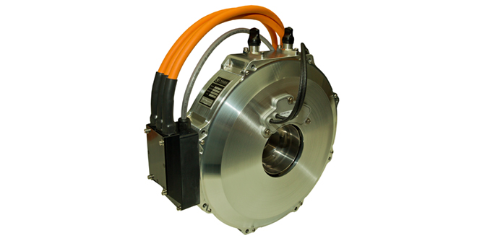
YASA Motors and Controllers for first converted US model of aircraft

Control Panels, Avionics and Power train components we do with our Michigan partners (see the pictures below) but in a future we have a plan to create a general facility “under one roof” in Oakland county. Business plan for all MEDA Project still under development and correction till we finish our first steps MEDA Project in 2020/2021.

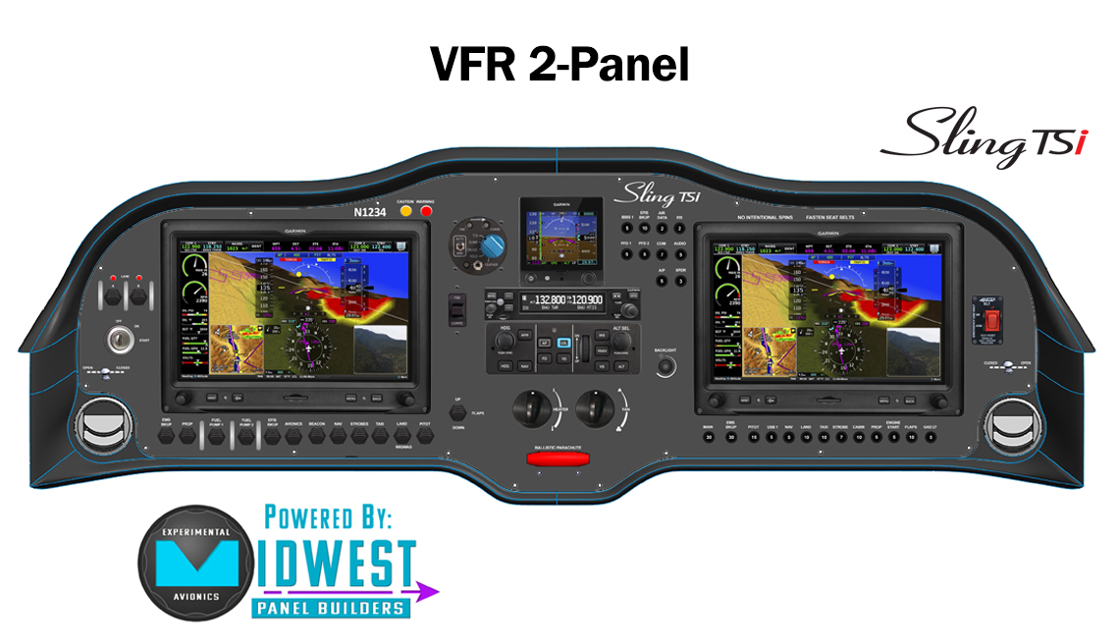
Avionics and Control panel for first e-Drive model

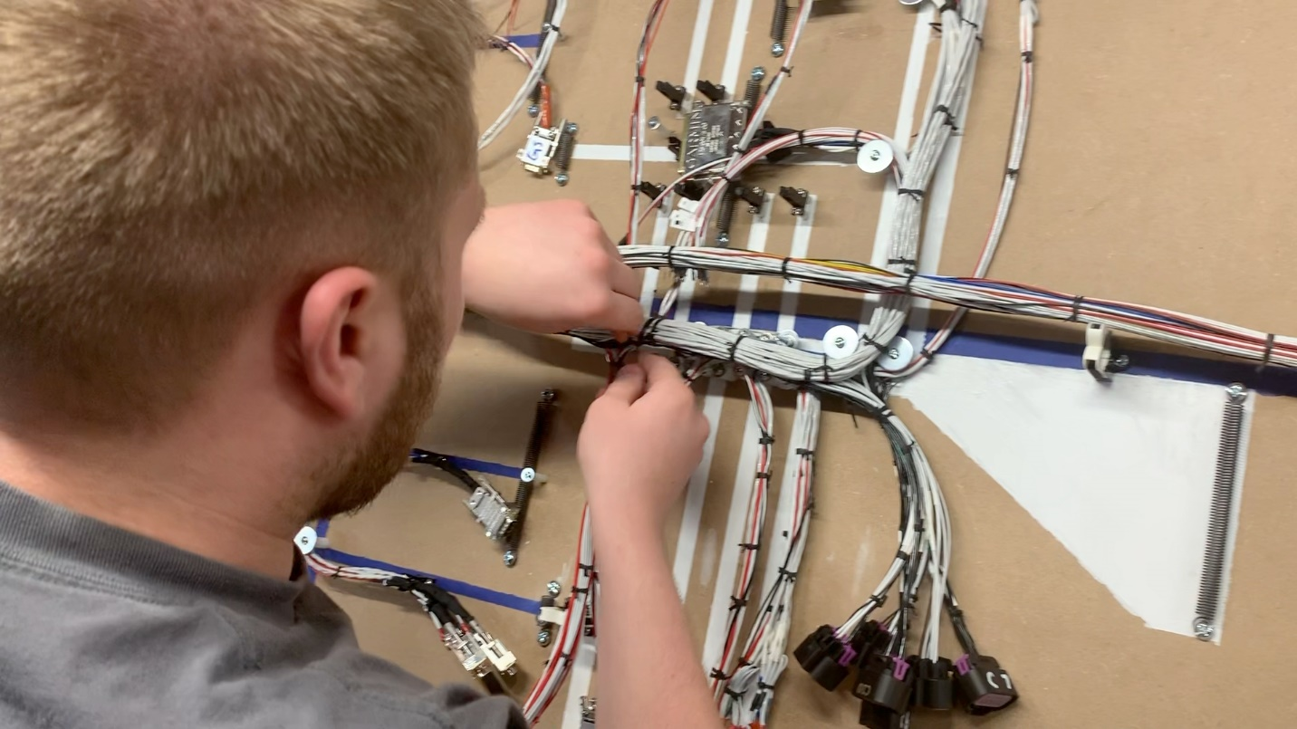
Control panels and Avionics assembly process in Lapeer, Michigan facility
Experimental Sling models assembly facility in Caro, Michigan

Existing and Futuristic analogs:

In current time some few existing electrical and hybrid aircrafts is a good example of MEDA Project and we try to use all interested technologies to create our Experimental model for test flights.
#1: Pipistrel Electric Plan
Pipistrel - supplies a simple Plug and Play system to OEM manufacturers and end users, to fast-track their entry into the electric aircraft industry. The advantage for OEM manufacturers is you are sourcing a tried, tested and proven system and there are already a large number of charging stations at airports around the world where the ALPHA Electro is already based.
Standardizing the charging network is really an important process in the global acceptance of electric aircraft as a future replacement for gasoline powered aircraft.
The exact same propulsion system that is used in the Taurus Electro and Pipistrel ALPHA Electro is available to government and other manufacturers. Everything we need for our electric aeroplane or self-launching glider is included in the one package. Custom projects are also supplied on a regular basis to government and military customers.
Pipistrel, this achievement injects additional motivation for the future eVTOL and multi-seat hydrogen-powered projects. Pipistrel is especially thankful to all our customers for their confidence in our products, which allows us to continue developing these innovative aircraft,” he added.
Pipistrel is the only company in the world currently selling four different electric aircraft models; the Taurus Electro, Alpha Electro and Alpha electro LC are now being complemented by the EASA type certified Velis Electro.
Pipistrel Vertical Solutions, the company’s R&D division, holds an EASA Design Organisation Approval and has the capability of bringing a new aircraft design concept from a basic idea into a certified design, ready for production. The division is also developing electric and hybrid-electric eVTOL air taxi and unmanned cargo delivery UAVs, as well as a hydrogen fuel-cell powered 19-seat miniliner/microfeeder, aimed at revolutionising the intra-European transport market.
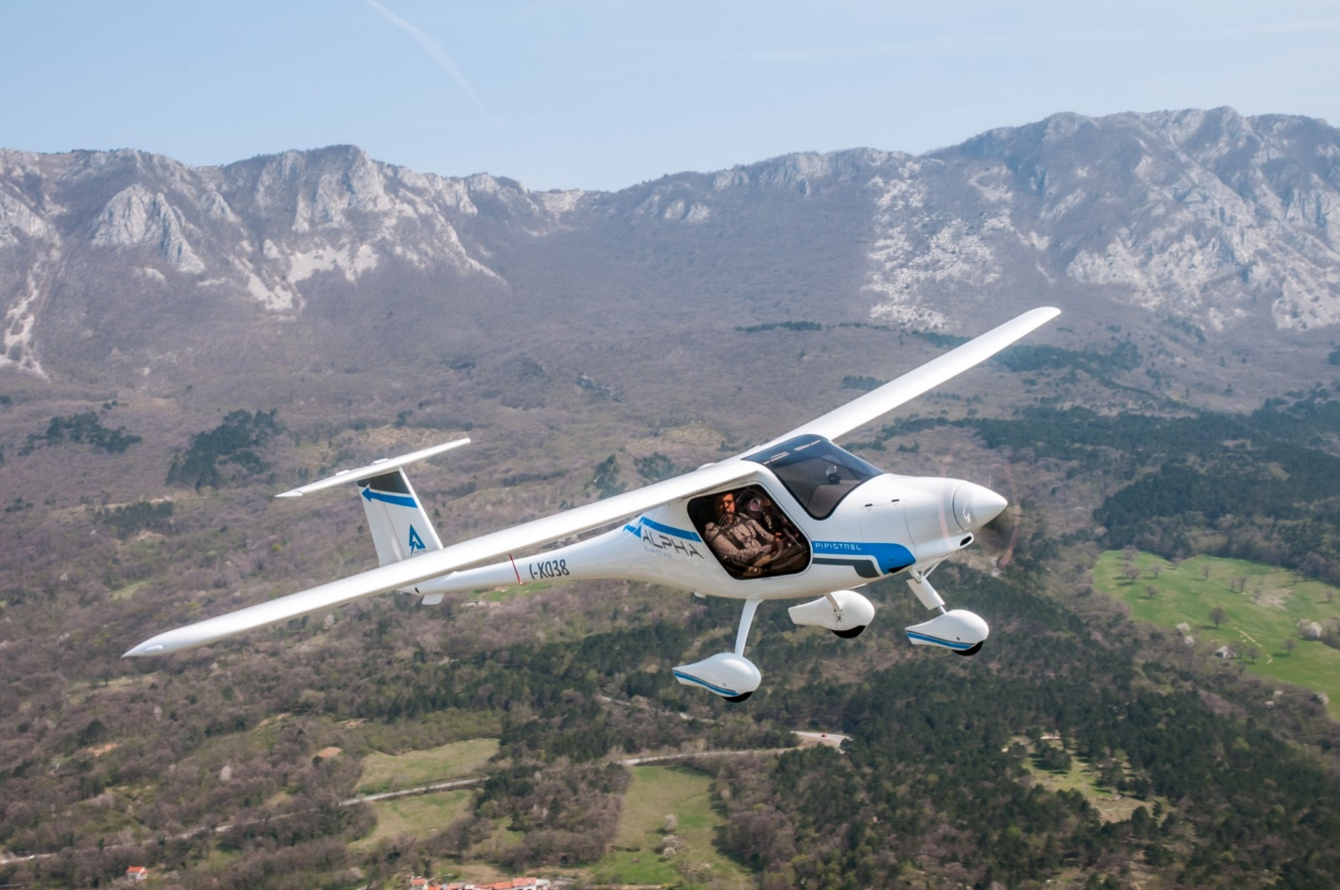
Performance of the ALPHA Electro 2-seat electric trainer is tailored to the needs of flight schools. Short take-off distance, powerful 1000+ fpm climb, and endurance of one hour plus reserve.The Alpha Electro is optimized for traffic-pattern operations, where 13% of energy is recuperated on every approach, increasing endurance and at the same time enabling short-field landings.
The ALPHA Electro is a completely new approach to flight training and at a cost nearly half that of our competitors.The new ALPHA Electro is an aircraft which is affordable to acquire, it is economical to maintain and we believe no other LSA training aircraft is as cheap to run as the new Pipistrel ALPHA Electro with its frugal operating costs, in most areas it could be as little as $3/hour for electricity to operate the aircraft.
#2: e-Caravan model
Cora, the world’s first all-electric, self-flying air taxi, resumed testing in both the US and New Zealand after a three-month delay because of Covid-19 concerns. Cora is considered one of the most advanced electric vertical takeoff and landing (eVTOL) aircraft, having gained its flight certificates in 2017. It was designed and is being developed by Wisk, an urban-air-mobility company backed by Boeing and Kitty Hawk.
The 21-foot bumble-bee-colored electric taxi has undergone more than 1,300 flight tests. With a 36-foot wingspan, Cora takes off vertically like a helicopter with its 12 independent lift fans, and flies like an airplane about 1,500 feet above the ground. Top speed is 100 mph, and with current battery technology, Cora has a 25-mile range.
The eCaravan was developed in conjunction with AeroTEC. “There’s no roadmap for testing and certifying electric aircraft—this is a new frontier,” said Lee Human, president and CEO of AeroTEC.
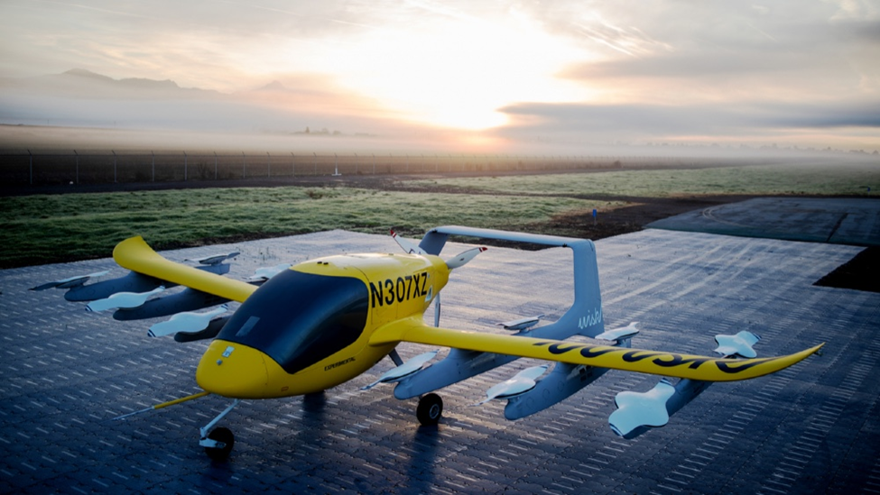

#3: MagniX full Electric commercial plane
One of the beauties of this new frontier is that the magniX engine can be used on older aircraft, extending their life far beyond the original design.
After last December’s record-setting electric seaplane demonstration with Harbour Air, magniX has recently set a more impressive record in a larger aircraft. The Harbour Air demonstration showed that a seaplane could work on an electric engine, but the converted Cessna Grand Caravan 208B now holds the title for the world’s largest commercial electric aircraft.

While the eCaravan is currently the world’s largest electric commercial aircraft, the MagniX electric engine could potentially be used in larger aircraft—though it might be some time before it moves to large jets.

The beginning of a new era
Conceived as a fundamental part of the ‘Velis Training System’, the Velis Electro was designed to be simple to operate and maintain, without compromising safety. Employing Pipistrel’s type certified electric engine, the Velis Electro delivers power instantly and without hesitation – using a simplified user interface in a cockpit that maintains the same look-and-feel of its conventionally powered siblings. The reduced number of moving parts dramatically decreases maintenance costs and the risk of malfunctions is further minimized thanks to its built-in continuous health-monitoring system.
This enhanced reliability allows the Velis Electro to have more than double the lifespan of powertrain elements in comparison to the previous generation of electric aeroplanes.
The revolutionary powertrain is entirely liquid-cooled, including the batteries, and demonstrated the ability to withstand faults, battery thermal runaway events, and crash loads as part of the certification process.
The overall result of all these breakthrough innovations is a drastic reduction in the operating costs, significantly contributing to the affordability of pilot training.
“The type certification of the Pipistrel Velis Electro is the first step towards the commercial use of electric aircraft, which is needed to make emission-free aviation feasible. It is considerably quieter than other aeroplanes and produces no combustion gases at all,” said Mr Ivo Boscarol, founder and CEO of Pipistrel Aircraft. “It confirms and provides optimism, also to other electric aircraft designers, that the Type Certificate of electric engines and aeroplanes is possible. The engine, which Pipistrel type certified separately, is also available to other aircraft OEMs.

Futuristic models for MEDA Projects
New class of aircraft that promises to revolutionize inter- and intra-city mobility. These aircraft, generally known as electric or hybrid-electric vertical takeoff and landing (eVTOL) vehicles, have the potential to improve the future of elevated mobility by moving people and cargo more quickly, quietly, and cost-effectively than traditional helicopters. In the initial paper, several challenges and/or barriers that would need to be overcome before seeing the wholesale adoption of eVTOL aircraft were identified

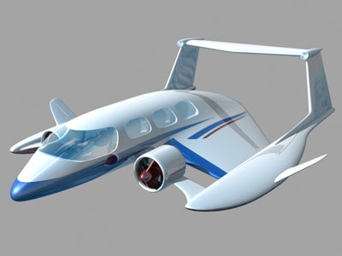
One of the best experimental models for our future project is WIG Craft-used ground effect low fly aircraft.
A ground-effect vehicle needs some forward velocity to produce lift dynamically and the principal benefit of operating a wing in ground effect is to reduce its lift depended drag. The basic design principle is that the closer the wing operates to an external surface such as the ground, when it is said to be in ground effect, the more efficient it becomes.
An airfoil passing through air increases air pressure on the underside, while decreasing pressure across the top. The high and low pressures are maintained until they flow off the ends of the wings, where they form vortices which in turn are the major cause of lift induced drag—normally a large portion of the drag affecting an aircraft. The higher the aspect ratio of the wing (that is, the longer and skinnier it is), the less induced drag created for each unit of lift and the greater the efficiency of the particular wing. This is the primary reason gliders have long and skinny wings.
Placing the same wing near a surface such as the water or the ground has the effect of greatly increasing the aspect ratio, but without having the complications associated with a long and slender wing, so that the short stubs on a GEV can produce just as much lift as the much larger wing on a transport aircraft, though it can do this only when close to the earth's surface. Once sufficient speed has built up, some GEVs may be capable of leaving ground effect and functioning as normal aircraft until they approach their destination. The distinguishing characteristic is that they are unable to land or take off without a significant amount of help from the ground effect cushion and cannot climb until they have reached a much higher speed.

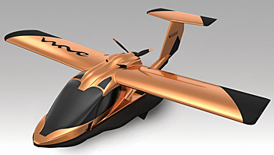
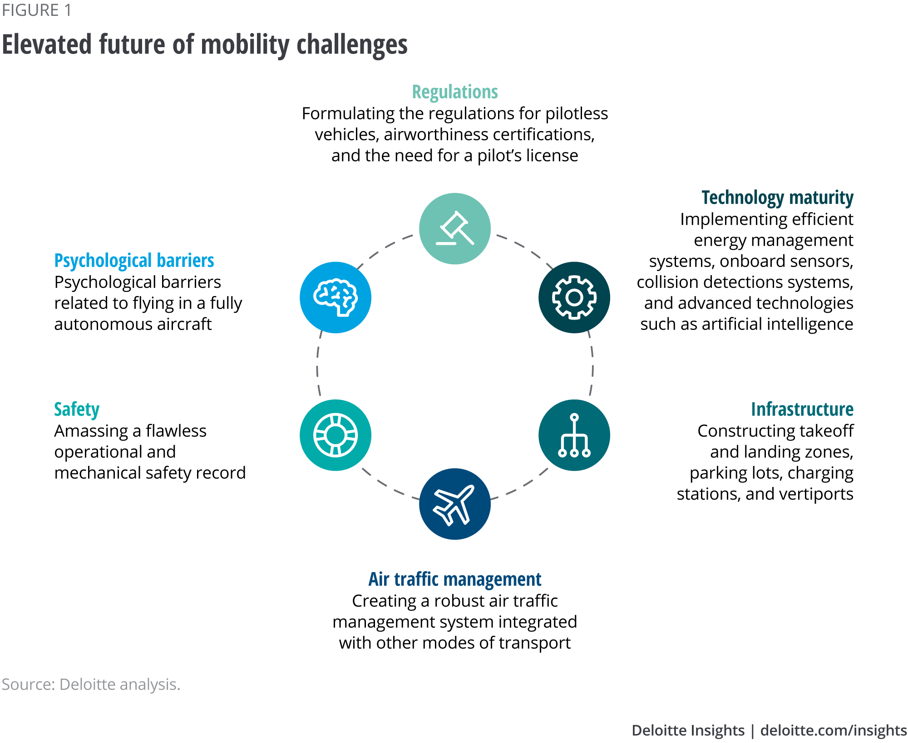
In a series of articles, the barriers to an elevated future of mobility have been highlighted, with recommended approaches provided for surmounting them. Through this process, we have come to view regulations as a subset of a holistic air traffic management system. The safety of eVTOLs will depend on eVTOL vehicle maturity, ground infrastructure, and the air-traffic management system.
The eVTOL evolution
Much has happened in just the last two years in the eVTOL journey. To tell a complete and timely story, here is a summary highlighting the main findings of the five Deloitte articles published, updating them where appropriate:
1) Elevating the future of mobility: Through the cumulative efforts of eVTOL manufacturers, operators, and other key stakeholders, elevated mobility will likely become a reality over the next decade. Despite challenges, manufacturers have begun testing vehicles; ecosystem participants are collaborating on developing a robust regulatory framework; and technology is advancing swiftly.
We focused on the movement of people, but over the course of our research, it became apparent that the movement of cargo is just as important. In fact, it will likely drive the early adoption of eVTOL aircraft. Similarly, while the initial focus has been on the end goal of fully autonomous vehicles, this under-acknowledges the potential that early eVTOL vehicles will most likely be piloted in order to accelerate commercialization. Overall, there has been rapid progress in the last two years, with many stakeholders believing: “If you build it, they will come.”
2) Managing the evolving skies: As the skies get busier, it is expected to be an ongoing challenge to manage and maintain an increasingly diverse airspace while keeping all air traffic moving safely and efficiently. A key enabler for the future of eVTOLs could be unmanned aircraft system traffic management (UTM), which would have to work in conjunction with existing air traffic management systems.
This “system of systems” is complicated to establish, but it is being pursued by a diverse group of stakeholders, including eVTOL operators, communication-system service providers, data-service providers, and regulatory authorities. Success depends upon all stakeholders having trust in the essential elements of the air-traffic management system. This will require reliable and available communication, predictable and consistent navigation, and accessible, trusted surveillance. These elements, coupled with tried-and-tested procedures, coordinated teams, redundancy, and continuous training, will be mission-critical in enabling the system to operate reliably and safely.
3) Psychological barriers to the elevated future of mobility: Social acceptance, or overcoming the psychological barriers, are expected to play a major role in shaping the eVTOL industry, as consumers are at the core of the elevated-mobility ecosystem. For this article, Deloitte questioned a global group of 10,000 consumers about their perception of fully autonomous eVTOL aircraft with respect to safety and perceived utility.
Nearly half of the respondents viewed autonomous aerial passenger vehicles as a potentially viable solution to roadway congestion. However, 80 percent of the total either believe that these vehicles “will not be safe” or are currently uncertain that they will be safe. eVTOL aircraft can become part of the new mobility ecosystem only when creators and operators convince skeptical consumers that airborne vehicles are both useful and safe. Shaping consumer attitudes will be the joint responsibility of regulators, creators, and operators of this new breed of aircraft.
4) Technological barriers to the elevated future of mobility: Several complex technological issues need to be addressed before air taxis and cargo transports take to the skies. These persistent challenges are primarily related to propulsion, situational-awareness systems, and advanced detection and collision-avoidance systems. While onboard technology is maturing quickly, efficient energy management (including battery capacity, speed of recharging, and cost per kilowatt-hour) remains a limiting factor and is proving to be a difficult challenge to solve. It will likely take a group effort to eliminate the remaining technological barriers to urban air mobility.
To strengthen collaboration within the ecosystem, participants should develop and work on an integrated framework—spanning manufacturing, operations, and certification—to advance technologies involved in eVTOL aircraft. This framework should provide a structure for encouraging collaboration within the ecosystem, harnessing electric propulsion technology through alliances and partnerships, leveraging advancements in ground autonomy, and investing in cognitive automation capabilities.
5) Infrastructure barriers to the elevated future of mobility: Although pilot projects are underway in major cities around the world, the infrastructure necessary to enable large-scale passenger and cargo transportation in urban and suburban areas is not yet in place. The missing pieces include the ground infrastructure (takeoff, landing, and service areas), a robust communication and UTM system, and a seamless mobility operating system. To pave the way for widescale deployment, eVTOL operators and local authorities (such as cities and municipalities) should start identifying feasible locations for components of the ground infrastructure, such as takeoff and landing, charging/refueling stations, parking facilities, maintenance, and contingency landing sites. They should also enlist the help of information technology providers, who can assist in building a well-connected infrastructure, and regulatory authorities, who can assist in designing a policy and control framework that is robust, safe and secure.

