George Rybchenko, Team Leader
ALTECHLAB Walled Lake, MI
January 23, 2017
Business Plan – BREAKTHROUGH TECHNOLOGY FOR Energy Storage systems

BACKGROUND
ALTECHLAB is an early stage product development laboratory concentrating on prototype development for energy storage and energy conversion applications. Through a global distributed research team, we are developing Energy Active Composite technology that will enable more efficient high-capacity Energy Storage Systems that are cheaper, safer, more efficient, and more environmentally friendly than today’s state-of-the-art Lithium batteries.

SUSTAINABLILITY CHALLENGES FOR ENERGY STORAGE SYSTEMS
ALTECHLAB’s research efforts are focused on addressing the need for reliable, high-capacity, long-run energy storage systems. Today’s most ubiquitous high capacity energy storage systems are Lithium batteries. These systems are typically high cost, with limited capacity (eg limited range of current Electric Vehicles). High-capacity Lithium batteries also carry a high risk of combustion, explosion and a host of environmental and disposal problems.

PROMISING NEW TECHNOLOGY OFFERS A SOLUTION
ALTECHLAB is developing a new Energy Active Composite technology using Magnesium and Graphene. This new technology with offer extra high capacity storage and it will be safe and environmentally friendly.

IMPROVING TODAY’S ENERGY STORAGE SYSTEMS
AlTechLab new Energy Active Composite technology has the potential to offer a 90% cost reduction from current Lithium systems. Lithium is found in only two locations worldwide and the global production is expected to fail to meet market needs in the future. This shortfall is expected to drive today’s high costs even further upward.

While energy capacity of Lithium energy storage systems is increasing (eg Sakti3), cost and limited capacity of Lithium systems remains an issue for large-scale storage devices such as Electric Vehicles. Energy Active Composite technology offers the potential to improve energy storage capacity (1 KW/Kilo may be possible) without current risks of fire, explosions and environmental hazards.

Safety issues also continue to be an issue even with smaller batteries, as demonstrated recently in Samsung’s problems with the Galaxy Tab 7. Larger batteries are expected to present even bigger risks in terms of combustion and explosions.

POTENTIAL APPLICATIONS
The proprietary Energy Active Composite technology that ALTECHLAB is developing has the potential to improve the range and capabilities of Electric Vehicles. A recent report from Lux Research projected that the global market for high-capacity batteries for Electric Vehicles would be worth $10 Billion by 2020. There are also other applications of Energy Active Composites in areas such as drones, lightweight, energy storage in clothing, LED/OLED displays, and printed electronics.

ACCELERATING TECHNOLOGY DEVELOPMENT AND COMMERCIALIZATION
Additional funding is needed to accelerate our research and help us to commercialize this technology. Without additional funding, we could miss critical windows to leverage our new energy active composite technology to support critical emerging applications such as Electric Vehicles.
In the near term, we see the potential to patent this technology and secure an annual license agreement worth $US5 Million to $US 50 Million. We are currently ensuring that technology has been validated through the test production phase (design, verification, protocol, report).

NEXT STEPS
- Obtain a financing in 2017 to finish advanced working prototypes and testing for Energy Active Composites technology.
- Complete upgrade of test lab and start test production in 2017-2018.
- Secure IP (Intellectual Property) certificate for future potential mass production to help attract additional investors/partners.
- Global sales and marketing to secure licensing and production partners in 2018-2020.
- Total project cost is projected to be US$3,128,000.

POSITIONED FOR SUCCESS
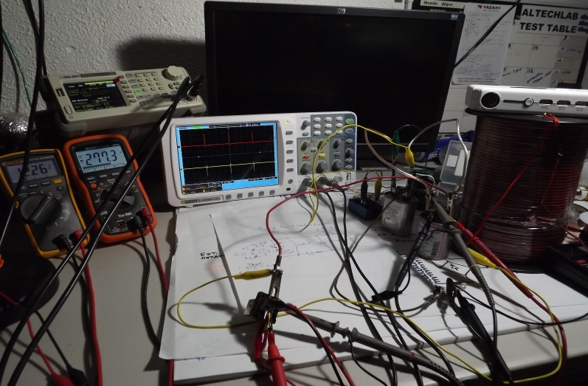
ALTECHLAB has a history of project development utilizing 3D design and a rich electrical engineering talent base associated with plasma generation and plasma reactions. We have designed a prototype quick-charging unit featuring Maxwell supercapacitors for small capacity applications such as electric scooters or as a small mobile power unit which could be used for military applications. ALTECHLAB has shown that using the proprietary pulsing techniques can be charged faster than with a constant current.
AlTechLab quick-charge first prototype featuring MiniMax batteries and supercapacitors.

ALTECHLAB TEAM
George Rybchenko – ALTECHLAB owner and team leader-Walled Lake, MI. Experienced engineer with a background in industrial electronics who has done contract work with large companies such as Echostar, Comcast, and Net.com
Nick Moroz-Consultant, Ann Arbor, MI
Olek Alekseychenko - Sr.Developer from Yazaki Corp., Canton, MI, USA

Andrey Krischenovich - TET Lab principal developer (NY)
Direct contact: (248) 872-5420

